Activity 3

**Question 1**

Before you can do this exercise, you'll need to download and unzip qf-298(2).zip

1. Go into SQL Server Management Studio;
2. Open the SQL file you've just unzipped (you can press CTRL + O to do this); then
3. Execute this script.

This will generate the database that you'll need to use in order to do this exercise

Create a report showing total quantity sold by family and centre type:

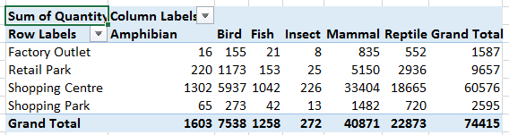

Create a measure to show in each cell total sales for that centre type and that family, divided by total sales for that centre type for all families.  The numerator can just show total sales:

The resulting table should look like this:

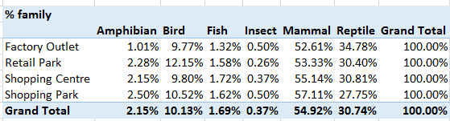

Try creating and showing another measure, this time to show sales as a percentage of all centre types:

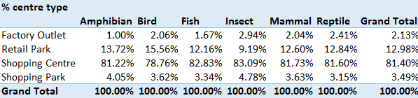

**Question 2**

|  |  |
| --- | --- |
| Exercise: | Create a ratio of sales between two different habitats, |

The aim of this exercise is to show the percentage of the values of sales for each region attributable to watery habitats.

In the **Purchase** table, create a measure to calculate the total value of sales for habitats with id numbers 3 and 4 (corresponding to fresh and salt water respectively).

You'll need to find sum (price * quantity)

Use this measure to show total watery sales by shopping centre type:

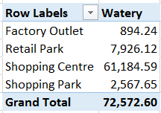

You should format your numbers to look nice!

Now create another (similar) measure called **Vegetation**, showing the total value of sales for vegetative habitats (id numbers 1 and 2, for grasslands and forest respectively).

Use this to create and show a third measure called **Water-to-veg ratio**, to get this table:

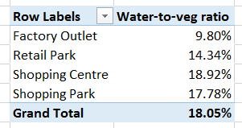

Factory outlets have the smallest ratio (surely a fact worth shouting about).

Save your report as **What about the desert**, then close it down.

**Question 3**

|  |  |
| --- | --- |
| Exercise: | Pick out only transactions whose price is a given amount. |

Before you can do this exercise, you'll need to unzip this file **qf-255.zip**

If you haven't already done so, run the SQL script in the above folder to generate a database called **MAM**.

Create a data model similar to this one:

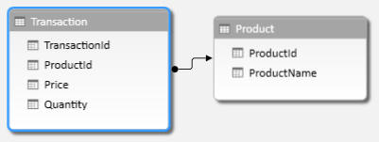

As long as you have these two tables, the details aren't important.

Create a table showing total quantity sold per product:

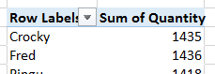

Now create and display two calculated fields,

One which shows the total quantity sold for goods where the price is £10 or more (call this **Expensive**); and One which shows the total quantity sold for goods where the price is less than £10 (call this one **Cheap**).

The final table should look like this:

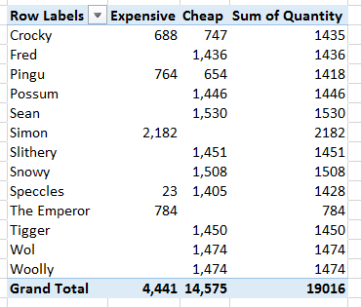

For each product, it would be worrying if the cheap and expensive columns didn't sum to the total!

Save this as **Partitioning the set**, and close it down.

**Question 4**

|  |  |
| --- | --- |
| Exercise: | calculate the ratio of total sales to sales for a specific type of animal. |

Create a data model similar to the one below (it doesn't matter what fields you hide from client tools, as long as you include these tables):

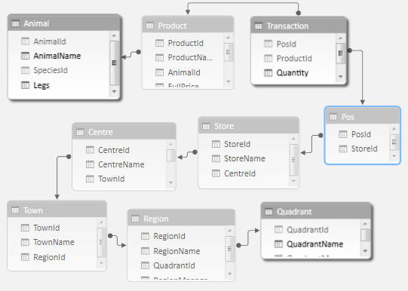

The tables to include, allowing us to link quadrants to animals.

Now create this table showing the number of legs for each animal across the top, and the quadrant name down the left-hand side:

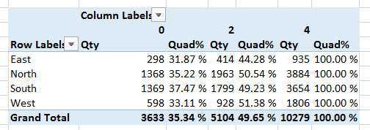

This table shows:

* The total quantity sold for each cell's query context; and
* The percentage this constitutes of the total for quadrupeds.

If you've got this working, add another calculated field which shows the percentage of the total for all leg types.

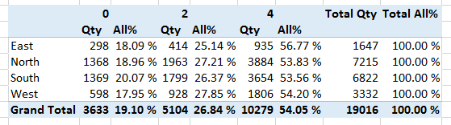

Reassuringly, the total on the right is 100%. Quadrupeds constitute just over 54% of total sales.

When you've finished, save this query as **Four legs good**, and close it down.

**Question 5**

|  |  |
| --- | --- |
| Exercise: | Divide sales by 4 legs and other for a measure,. |

Before you can do this exercise, you'll need unzip [qf_](https://www.wiseowl.co.uk/files/execise-question-files/qf-178.zip)178 To start, if you haven't already done so run the script in the above folder to generate the **MAM** database (not for commercial use or copying).

Create the following data model:

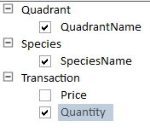

Use this to create the following table:

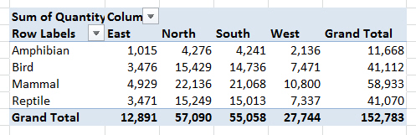

This tables shows total quantities sold by quadrant and species.

Add a measure which (you think) should give the total quantity sold for four-legged animals only:

Amend your measure and add another one to report on total quantity sold by quadruped and non-quadruped:

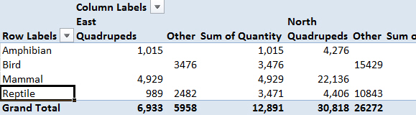

The figures to watch are those for reptiles, since this species includes snakes (0 legs) and crocodiles (4 legs).

When you've got this working, save as **Four legs good** (you may well need it again soon!), and close it down.